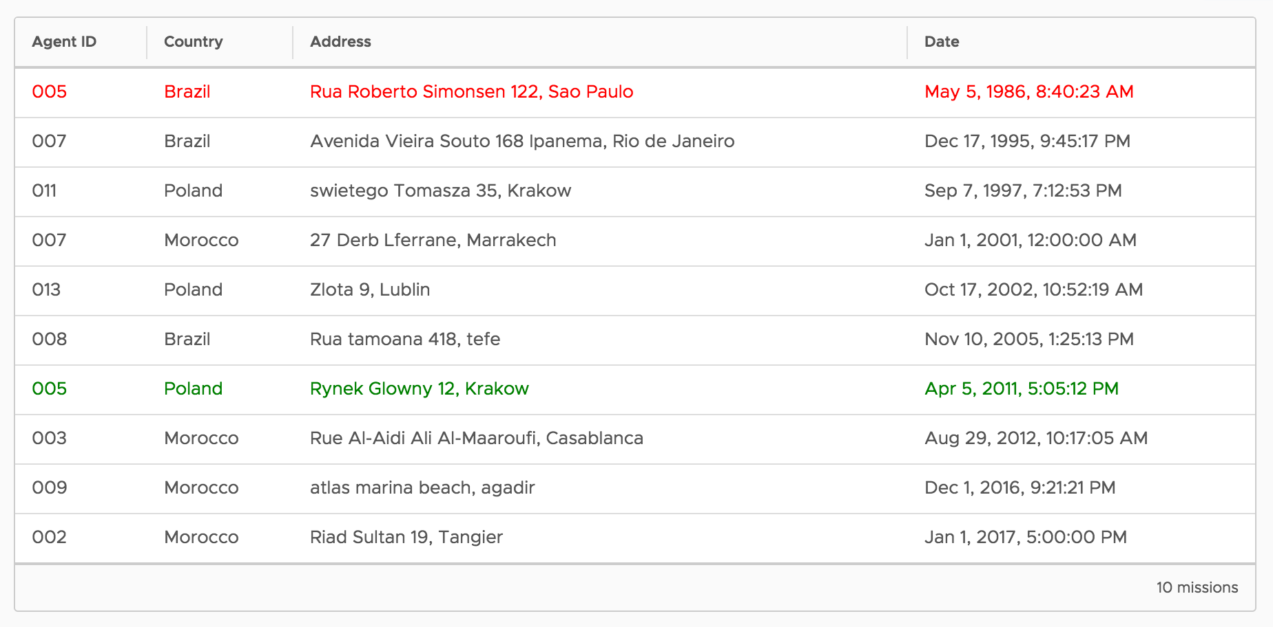
Tikal’s Code Challenge

You can use whatever IDE you choose. When you are done either create a public github repo or zip the project and send it (remember to not include the “node_modules” directory)

* Try to implement with high scale considerations and edge cases in mind.

Recommendation: read everything before you start to implement.

Good morning, agent. MI6 is trying to gather statistics about its missions.
Your mission, should you decide to accept it, has two parts.

Part 1:
Endpoint: GET /countries-by-isolation
An isolated agent is defined as an agent that participated in a single mission.
Implement an algorithm that finds the most isolated country (the country with the highest degree of isolation).
For the sample input (see below) input:
- Brazil has 1 isolated agent (008) and 2 non-isolated agents (007, 005)
- Poland has 2 isolated agents (011, 013) and one non-isolated agent (005)
- Morocco has 3 isolated agents (002, 009, 003) and one non-isolated agent (007)
So the result is Morocco with an isolation degree of 3.

Part 2:

- Find the closest and farthest missions from a specific address
(you can use Google API for this)

Endpoint: POST /find-closest
Body: { “target-location”: “[a address or geo coordinates]”

Bonus:
Write a simple web app that will consume the endpoints and visualize the results

Your task is to write a service that uses any type of DB (pre-populated with the sample data) and exposes the above endpoints. You can use any framework you see fit (Express, Resitify etc.) or just vanilla Nodejs.

Sample data:
[
{agent: '007', country: 'Brazil',
address: 'Avenida Vieira Souto 168 Ipanema, Rio de Janeiro',
date: 'Dec 17, 1995, 9:45:17 PM'
},
{agent: '005', country: 'Poland',
address: 'Rynek Glowny 12, Krakow',
date: 'Apr 5, 2011, 5:05:12 PM'
},
{agent: '007', country: 'Morocco',
address: '27 Derb Lferrane, Marrakech',
date: 'Jan 1, 2001, 12:00:00 AM'
},
{agent: '005', country: 'Brazil',
address: 'Rua Roberto Simonsen 122, Sao Paulo',
date: 'May 5, 1986, 8:40:23 AM'
},
{agent: '011', country: 'Poland',
address: 'swietego Tomasza 35, Krakow',
date: 'Sep 7, 1997, 7:12:53 PM'
},
{agent: '003', country: 'Morocco',
address: 'Rue Al-Aidi Ali Al-Maaroufi, Casablanca',
date: 'Aug 29, 2012, 10:17:05 AM'
},
{agent: '008', country: 'Brazil',
address: 'Rua tamoana 418, tefe',
date: 'Nov 10, 2005, 1:25:13 PM'
},
{agent: '013', country: 'Poland',
address: 'Zlota 9, Lublin',
date: 'Oct 17, 2002, 10:52:19 AM'
},
{agent: '002', country: 'Morocco',
address: 'Riad Sultan 19, Tangier',
date: 'Jan 1, 2017, 5:00:00 PM'
},
{agent: '009', country: 'Morocco',
address: 'atlas marina beach, agadir',
date: 'Dec 1, 2016, 9:21:21 PM'
}
]

This message will self-destruct in 2 hours!

Good luck.

